**EGERTON**  **UNIVERSITY**

**ONLINE LIBRARY SYSTEM PROJECT**

**SDD**

**S13/02367/19**

**MOURICE ADERO**

**Table of content**

Table of Contents

**List Of Figures** ii

**Chapter 1** 1

**Introduction** 1

**Document Overview** 1

**Intended Audience** 1

**Product Scope** 1

**Chapter 2** 2

**System Architecture** 2

**System Overview** 2

**System Components** 2

**System Interfaces** 2

**Hardware and Software Requirements** 2

**Security Requirements** 2

**Chapter 3** 4

**File and Database Design** 4

**Database Overview** 4

**Database Design** 4

**Entity Relationship Diagram** 4

**Database Security** 5

**Chapter 4** 6

**Human Machine Interface** 6

**User Interface Design** 6

**User Requirements** 6

**User Input Validation** 6

**Output Design** 8

**Error Handling** 8

**Chapter 5** 9

**Detailed Design** 9

**Detailed System Design** 9

**System Modules and Components** 9

**Algorithms and Procedures** 9

**Testing and Validation** 9

**Chapter 6** 10

**System Integrity Controls** 10

**Glossary** 11

# **List of Figures**

Figure 1: ER Diagram 4

Figure 2: Input Validation 7

Figure 3: Signup Validation 7

# **Chapter 1**

## **Introduction**

The purpose of this document is to provide a detailed description of the design and implementation of an online library system. This document outlines the various features and functionalities of the system, as well as the hardware and software requirements needed to run the system effectively.

**Document Overview**

This software design document (SDD) provides a comprehensive guide to the development of the online library system. It presents a detailed description of the various aspects of the system, including system architecture, hardware, software, file and database design, human-machine interface, system integrity controls, and detailed design.

**Intended Audience**

This document is intended for various stakeholders involved in the development and implementation of the online library system. This includes project supervisor, the examiners and any part that will be interested in making any improvements to the online library system in the future. It also includes potential users of the system who may want to gain a deeper understanding of how the system works.

**Product Scope**

The online library system is designed to provide users with access to a virtual library where they can search, request, and read books from anywhere at any time. The system is intended to be user-friendly and easy to navigate. It is also designed to be scalable and flexible to accommodate future expansions and modifications.

# **Chapter 2**

## **System Architecture**

### **System Overview**

The online library system is a web-based application designed to provide an efficient way of managing library resources, including books, newspapers, and other materials. The system enables administrators to add items, manage registered users and respond to requests from users who are requesting for materials.

### **System Components**

The online library system is composed of several components, including the user interface, the database, the application server, and the web server. The user interface provides access to the system and allows users to perform various tasks such as searching for books, requesting materials, reading blogs and managing their accounts. The database stores all the data related to the library resources, users, user requests, and other related information. The application server provides the necessary logic for processing user requests, while the web server serves the web pages to users.

### **System Interfaces**

The online library system has two main interfaces, the user interface and the administrative interface. The user interface provides access to the system for online library users, while the administrative interface is used by administrator to manage the system's resources and users. The interfaces provide an intuitive way for users and administrators to interact with the system, making it easy to use and manage.

### **Hardware and Software Requirements**

The system architecture chapter also specifies the hardware and software requirements for the online library system. The hardware requirements include the server hardware and client devices. The software requirements include the operating system, web server, application server, database management system, and other software components necessary for the system's operation.

### **Security Requirements**

The security requirements for the online library system are also defined in the system architecture chapter. The system must ensure the confidentiality, integrity, and availability of the data stored within the system. The security measures include authentication and authorization mechanisms, data encryption and access control. The security requirements ensure that the online library system is secure and protected from unauthorized access and data breaches.

# **Chapter 3**

## **File and Database Design**

### **Database Overview**

The file and database design are an essential part of the online library system. This chapter outlines the database overview and design considerations for the system.

### **Database Design**

The database design involves identifying the data that needs to be stored and organizing it into tables. The online library system database includes tables for items, requests, users and blogs.

### **Entity Relationship Diagram**

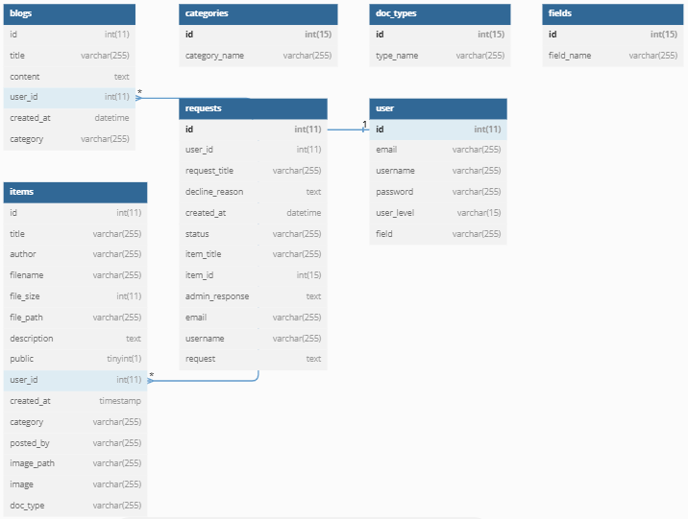The Entity Relationship Diagram (ERD) is a graphical representation of the entities and their relationships in the database. The ERD for the online library system includes entities such as items, users, document types, categories, and requests, and illustrates their relationships.

Figure : ER Diagram

### **Database Security**

The online library system contains sensitive information such as user information and requests history. Therefore, the database must have robust security measures in place to protect against unauthorized access, data breaches, and hacking attempts. This chapter outlines the database security requirements for the online library system, including access control, data encryption, and regular backups.

# **Chapter 4**

## **Human Machine Interface**

### **User Interface Design**

The user interface design for the online library system is intuitive, user-friendly, and aesthetically pleasing. The design is easy for users to navigate the system and quickly find the information they need. The interface includes features such as a search bar and filters options to help users find specific items.

### **User Requirements**

The user requirements for the online library system include the ability to browse the library's collection, search for specific items, view item details, and request for items. Users are able to get feedback on their requests and they can download items of interest for latter uses if they need.

### **User Input Validation**

The system validates user input to ensure that it is correct and complete. This includes checking that user inputs conform to the expected format (such as email addresses or secure passwords) and ensuring that required fields are not left blank.

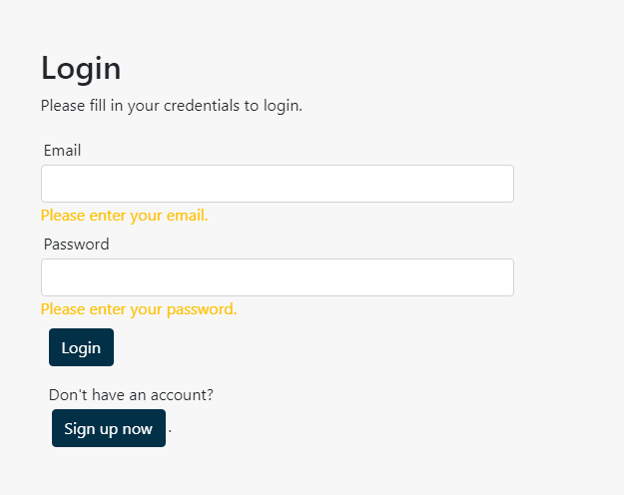

Figure 2: Input Validation

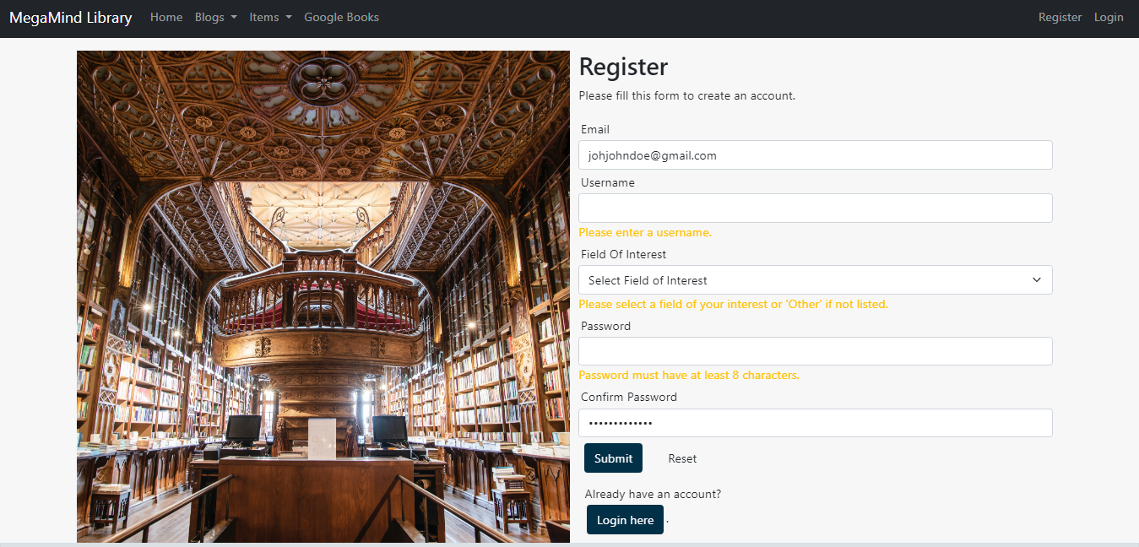

Figure 3: Signup Validation

### **Output Design**

The output design presents information in a clear and concise manner. This includes item details, list of requests, and other user-related information. The system gives and interface where users can download items they are interested in as pdfs.

### **Error Handling**

The system provides appropriate error messages to users in the event of input errors, system errors, or other issues. The error messages are clear and concise and provide information on how to resolve the issue.

# **Chapter 5**

## **Detailed Design**

In this chapter, the detailed design of the online library system is presented. It includes a description of the system modules and components, algorithms and procedures, integration with other systems, and testing and validation.

### **Detailed System Design**

The detailed system design includes a description of the system architecture, software components, and hardware components. It also includes the system flow diagram and system interfaces.

### **System Modules and Components**

The online library system is made up of several modules and components that work together to provide the required functionality. The system modules include the user interface module, search module and administration module. The components include the database management system, web server, and the application server.

### **Algorithms and Procedures**

The algorithms and procedures used in the system are documented in this section. It includes the algorithms for searching, filtering, and downloading books. It also includes the procedures for adding and updating books, managing user accounts, and generating reports.

### **Testing and Validation**

The online library system is tested and validated to ensure that it works as intended. The testing procedures include unit testing, integration testing, and system testing. The validation procedures include user acceptance testing and performance testing. The testing and validation procedures are documented in this section.

# **Chapter 6**

## **System Integrity Controls**

System Integrity Controls are critical for ensuring that the online library system functions correctly, securely, and efficiently. In this chapter, we will describe the various measures taken to ensure that the system remains secure and free from any errors, failures, or data loss.

System Security Controls: To prevent unauthorized access and protect against cyber threats, the online library system has implemented various security controls, such as authentication, authorization, and encryption. Authentication is the process of verifying the identity of the user, and authorization is the process of determining the level of access a user has. Encryption is used to ensure that sensitive data is protected from unauthorized access and can only be read by authorized users.

Data Integrity: Data integrity is essential for ensuring the accuracy and reliability of data in the system. To ensure data integrity, the online library system has implemented data validation checks, data normalization, and data backups. Data validation checks ensure that data entered into the system is accurate and meets the required format. Data normalization ensures that the data is consistent and free from any duplication. Data backups are created regularly to ensure that in the event of a failure, the system can be restored to its previous state.

## **Glossary**

User Interface (UI): The visual and interactive aspects of a software system that allow users to interact with it.

Database: A structured collection of data that is stored and managed on a computer system.

ERD - Entity Relationship Diagram: A diagram that shows the relationships among entities in a database.

Algorithm: A set of step-by-step instructions for solving a problem or performing a task.

Procedure: A set of instructions for performing a specific task within a software system.

Integration: The process of combining different software systems or components to create a unified whole.

Validation: The process of checking that a software system meets its intended requirements.

Security Controls: The measures taken to protect a software system from unauthorized access or use.

Data Integrity: The accuracy and consistency of data over its entire life cycle.